Ideation Phase
Define the Problem Statements

Date | 30 September 2026
Team ID | SWTID-2026-7361
Project Name | AI Blog Nest API
Maximum Marks | 2 Marks

Customer Problem Statement Template:
Create a problem statement to understand your customer's point of view. The Customer Problem Statement template helps you focus on what matters to create experiences people will love.
A well-articulated customer problem statement allows you and your team to find the ideal solution for the challenges your customers face. Throughout the process, you’ll also be able to empathize with your customers, which helps you better understand how they perceive your product or service.
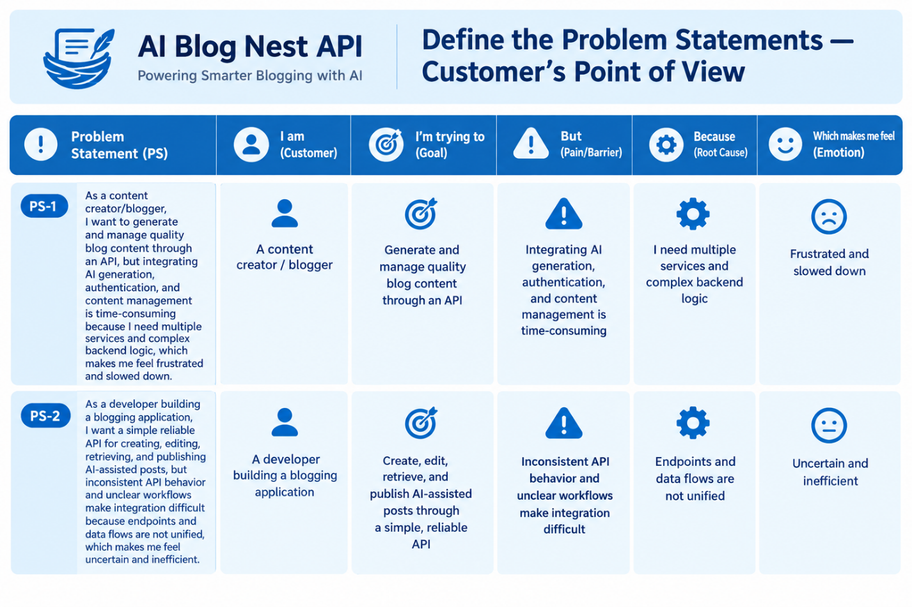
Example:

Problem Statement (PS) | I am (Customer) | I’m trying to | But | Because | Which makes me feel
PS-1 | A content creator / blogger | Create and manage quality blog content using an API | Creating AI-generated content, authentication, and managing posts takes too much time | I need to work with multiple services and complex backend logic | Frustrated and slowed down
PS-2 | A developer building a blogging application | Create, edit, retrieve, and publish AI-assisted blog posts through one reliable API | The API workflows are inconsistent and difficult to integrate | AI generation, authentication, and blog management are not unified | Uncertain and inefficient
PS-3 | A website / application owner | Provide fast AI-powered blog creation for users | Integrating AI features into the existing application is complicated | AI services require separate APIs, configurations, and error handling | Overwhelmed and concerned
PS-4 | A blogger managing multiple posts | Automate the complete blog workflow | I have to manually handle content generation, editing, and publishing | There is no simple unified workflow for these operations | Tired and frustrated
PS-5 | A developer integrating AI features | Connect AI content generation with secure user authentication | Managing authentication and AI requests separately increases development effort | The backend requires multiple endpoints and integrations | Confused and slowed down

